Q1 Number classification
check_num() {
if [$num -gt 0]; then
echo "Positive"
else if [$num -lt 0]; then
echo "Negative"
else
echo "Zero"
fi
}
read -p "Enter num: " num
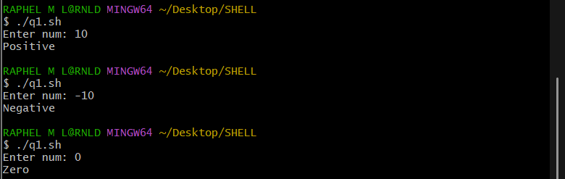
check_num $num

Q2 Factorial of a number
read -p "Enter num: " num
fact=1

while [ $num -gt 0 ]; do
fact=$((fact * num))
num=$((num - 1))
done

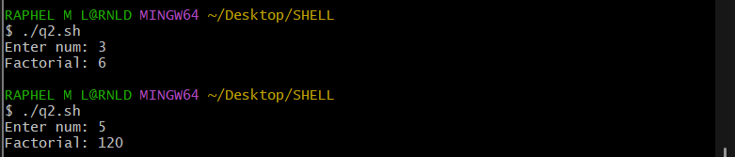
echo "Factorial: $fact"

Q3 Sum of N numbers
sum() {
sum=0
for ((i=0; i<=$1; i++)); do
sum=$((sum + i))
done
echo "Sum: $sum"
}
read -p "Enter num: " num

sum $num

Q4 Prime Number
check_prime() {
flag=0
for ((i=2; i<=$1/2; i++)); do
if (($1 % i == 0)); then
flag=1
break
fi
done

if [ $flag == 0 ]; then
echo "Prime"
else
echo "Not Prime"
fi
}

read -p "Enter num: " num
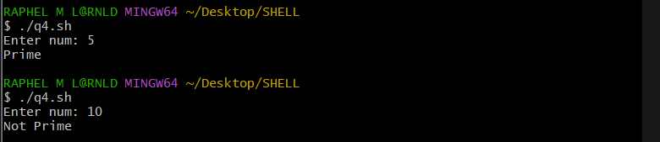
check_prime $num

Q5 Reverse a number
read -p "Enter num: " num

rev=0
while (($num > 0)); do
digit=$((num % 10))
rev=$((rev * 10 + digit))
num=$((num / 10))
done

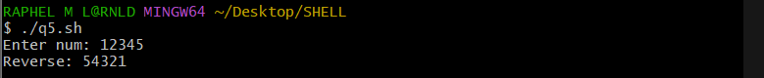
echo "Reverse: $rev"

Q6 Check file existence and permission
check_file() {
permissions=()
if [ -e "$1" ]; then
echo "File $1 exists !!!"
[ -r "$1" ] && permissions+=("Read")
[ -w "$1" ] && permissions+=("Write")
[ -x "$1" ] && permissions+=("Execute")
echo "Permissions: ${permissions[@]}"
else
echo "File does not exists !!!"
fi
}

read -p "Enter filename: " filename
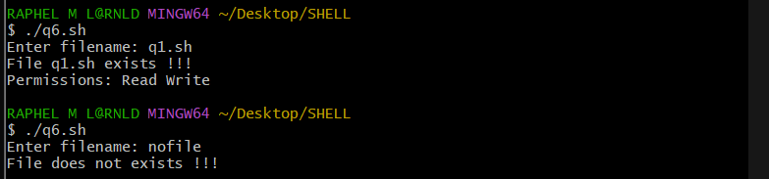
check_file "$filename"

Q7 Menu-driven calculator
operation() {
[ "$1" == "+" ] && result=$(($2 + $3))
[ "$1" == "-" ] && result=$(($2 - $3))
[ "$1" == "*" ] && result=$(($2 * $3))
[ "$1" == "/" ] && result=$(awk "BEGIN{print $2 / $3}")
echo "Result: $result"
}
while [ 1 ]; do
echo "****************calculator*****************"
read -p "Choose operation(+,-,*,/)(x => exit): " op

if [[ "$op" == 'x' ]]; then
echo "Exiting..."
break
fi

if [[ "$op" == '+' || "$op" == '-' || "$op" == '*' || "$op" == '/' ]]; then
read -p "Enter num1: " n1
read -p "Enter num2: " n2
operation "$op" $n1 $n2
else
echo "Invalid ! Enter valid input"
fi
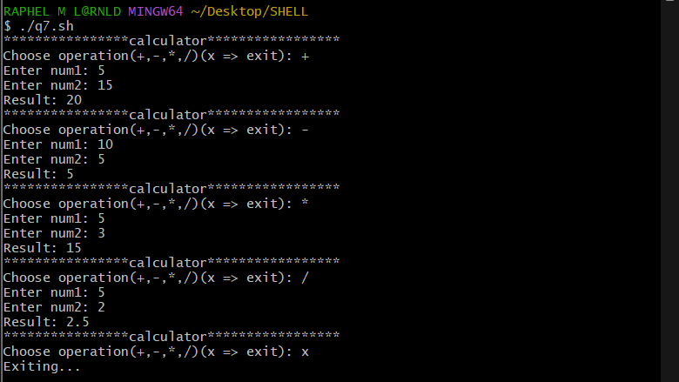
done

